Search Skills
DG Interns Hub | Week 1 | TryHackMe Room Writeup

Objective
Practise finding reliable cybersecurity information using effective searches.

Activity summary
Used search operators and evaluated information sources to locate answers.

Key learning
Search operators, source credibility and verification.

Evidence
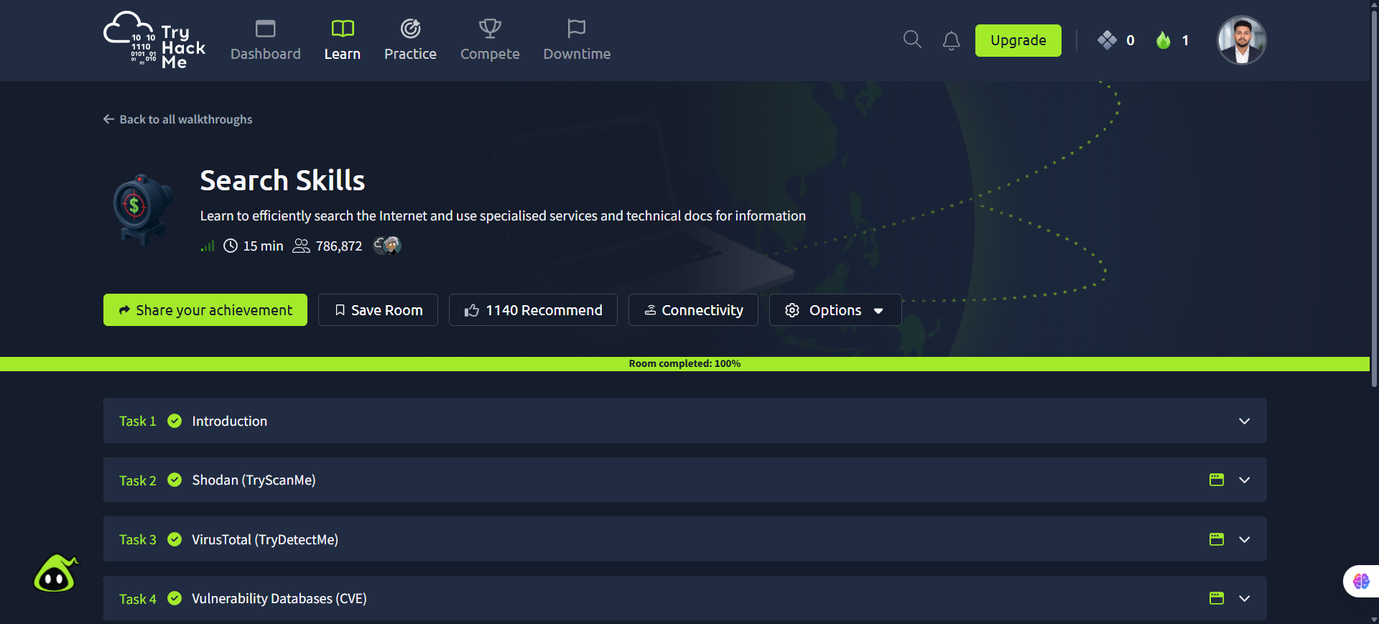
Screenshot: Search_Skills.png
Completion screenshot provided; the original step-by-step room answers were not included in the archive.

